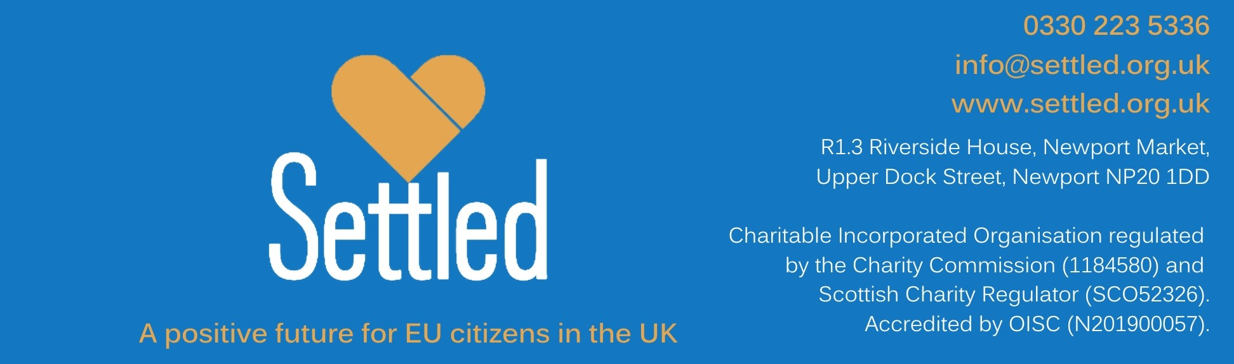

Recruitment of new Settled trustees

ABOUT SETTLED

Settled was set up as a charity in July 2019 to provide information, advice and support to vulnerable EU citizens living in the United Kingdom, so that they can lawfully continue to live, and work in the United Kingdom and be united with their families after the departure of the United Kingdom from the European Union.

Settled endeavours to reach vulnerable European citizens, inform and support them in their application for the EU Settled Status so that they and their families are not left without rights post Brexit.

After just four years, Settled is widely known as a trusted source of support for EU citizens in the United Kingdom and their families, highly respected by government and organisations operating in the field of immigration.

Settled believes that EU citizens who have made their home in the UK should be allowed to continue to do so lawfully, safely and successfully, and enjoy the rights granted to them by the Withdrawal Agreement.

We are a multinational team of well informed and dedicated professionals and volunteers. Our outreach ensures that our beneficiaries enjoy expert practical advice and support in 15 European languages. Thanks to over 100 volunteers, we understand the needs and concerns of vulnerable EU citizens at risk of being left without rights from the immigration policies of the United Kingdom following its departure from the European Union. Without being dramatic, we aim to avoid another Windrush scandal with EU citizens this time.

So far, we have helped more than 30,000 people face to face and many more through our digital platforms.

Since March 2022, we have also provided advice and support to Ukrainians coming to the UK under the government’s Ukraine Family Scheme, Homes For Ukraine Scheme, and Ukraine Extension Scheme.

ABOUT THE BOARD OF TRUSTEES

Should your application be successful, you will join a small team of trustees who are passionate about supporting the rights and wellbeing of EU citizens in the UK after Brexit.

Half our board members are EU citizens living in the United Kingdom.

We have a detailed role description and person specification over the next few pages to help you understand the requirements of the role.

The Main Purposes of the Trustee Role

As trustees at Settled, we are volunteers with a specific legal responsibility to:
- Ensure the aims and objectives of Settled are being met
- Act in the best interest of the charity
- Manage responsibility for what we have (our people, our money etc)
- Act with reasonable care and skill

You can find more information about being a charity trustee from the Charity Commission.

WHAT YOU WILL GAIN

- An insight into how a charity runs, particularly how a charity board runs
- A sense of pride when hearing about the difference our services make and that you have had a role in preserving the rights of EU citizens in the UK
- Confidence in building relationships with a wide range of people
- Confidence to operate at board level
- An opportunity to use your skills, knowledge and experience to the benefit of the charity

Being a trustee is a voluntary role and is not paid, but reasonable expenses including for travel are reimbursed.

You will receive a full induction to help you in the role at Settled CIO. In addition, where there is a training need, a range of training courses are on offer. You’ll need to commit time and energy to attend these, building up your knowledge so that you feel confident in the role.

TRUSTEE ROLE DESCRIPTION

ROLE: Trustee
REPORTS TO: Chair of Trustees
ACCOUNTABLE TO: EU citizens in the United Kingdom
Charities Commission and Companies House
SUMMARY: The Board supports the vision and mission of the organisation that EU citizens should continue to lawfully live, work and be united with their families in the United Kingdom post the United Kingdom leaving the European Union.
REMUNERATION: Being a trustee is a voluntary role and is not paid, but reasonable expenses including for travel are reimbursed.

Principal Role:

Vision and Mission
- To uphold the values of the charity, undertaking the duties of trusteeship in a way that adds to public confidence and trust in the charity
- To provide strategic leadership to the charity
- Promoting and developing the charity in order for it to grow and maintain its relevance to society
- To support decisions that are in the best interest of service users, donors, volunteers and stakeholders at all times
- To take big decisions about the future

Compliance, quality and effectiveness
- Support development of policies that further the aims and objectives of Settled and to monitor their success
- Ensure compliance with our memorandum and articles
- Ensure Settled’s accountability and legal obligations
- Maintain sound financial management of the charity’s resources, ensuring expenditure is in line with the organisation’s objects and its activities meet accepted standards and policies
- Ensuring resources are used in an efficient and cost effective manner
- Maintain effective board performance
- Remain aware of the legal responsibilities and liabilities of trusteeship and act in accordance with liabilities
- Manage/declare any personal conflicts of interest
- Strive for best practice in governance

TRUSTEE PERSON SPECIFICATION

KEY SKILLS

- Knowledge of and ability to carry out the core responsibilities of being a charity
trustee
- Able to think about the ‘bigger picture’ and longer term (5 years ahead) as well as to think about the ‘here and now’ (being strategic versus being operational)
- Able to act as an ambassador for Settled, promoting our work to friends and colleagues
- Able to comment, challenge or question in a way that is helpful, supportive and
constructive
- Timely and clear in your communication on and around meetings or projects

QUALIFICATIONS AND EXPERIENCE

You will have skills and experience in ANY of the following areas:

- Risk and financial management
- Strategic development
- Communications
- Fundraising
- IT and systems management
- Experience of working in senior teams, preferably at board level
- Experience of volunteering/working in the voluntary sector, preferably in the field of immigration.

Experience of being an EU citizen living in the United Kingdom would be an advantage.

PERSONAL ATTRIBUTES

- Integrity and honesty
- Proactive
- Demonstrable commitment to Settled's aims and values
- Team player, flexible and adaptable
- Willingness to learn about immigration issues.

TIME COMMITMENT

- Currently there is a board meeting every two months (currently two hours online)
- One to two away-days per year, a mix of week days and weekends
- Optional one hour sub-committee meetings (currently online)

- Prior to meetings spending about one or two hours reading and absorbing information, reflecting and discussing by telephone
- Follow up to meetings – reading and commenting on minutes, carrying out any
agreed actions

RESTRICTIONS

- Over 18
- Not bankrupt
- Subject to satisfactory DBS check and references
- Not excluded by Companies House or Charity Commission
- Conflicts of interest that would be so significant as to undermine the role in general.

NEXT STEPS

You’ve read the pack, and you:
- Feel inspired by the work of Settled
- Feel you could make a good trustee

It’s time to apply with a short CV and a statement explaining why you are the person to be Settled’s new trustee.

PLEASE SEND YOUR APPLICATION BY 1ST AUGUST 2023 to trustees@settled.org.uk

All applications will be reviewed against the role description and person specification by a small team of trustees and the CEO.

Everyone will be contacted by email or phone with regards to the success of your application at this stage. You will have the opportunity to get feedback if you are not successful.

If you have been shortlisted, you’ll be invited for a one hour interview with two trustees and the CEO at a mutually convenient time.

We expect you’ll have more questions. If so you can get in touch with Kate, our CEO, or myself, Martine, the Chair, as between us we are likely to know most of the answers! Please email trustees@settled.org.uk

